**LIT TRAINING**

**Batch Name : SAP ABAP ON HANA** **DAY7 ASSIGNMENT**

**EMPLOYEE ID – 46255244** **DATE : 09th September, 2022**

**1-Q Create an Upload program Using BDC Call Transacion to update data in VA01(Sales Order) .**

* **UPLOAD THE DATA USING FI01 TRANSACTION CODE.BEACAUSE** **WHEN WE USE TCODE(VA01) ,RUN TIME ERROR IS OCCURED DUE TO SERVER ISSUE - CHANGE IN KNA1 TABLE**

**STEP 1: CREATE A NEW RECORDING IN SHDB.**

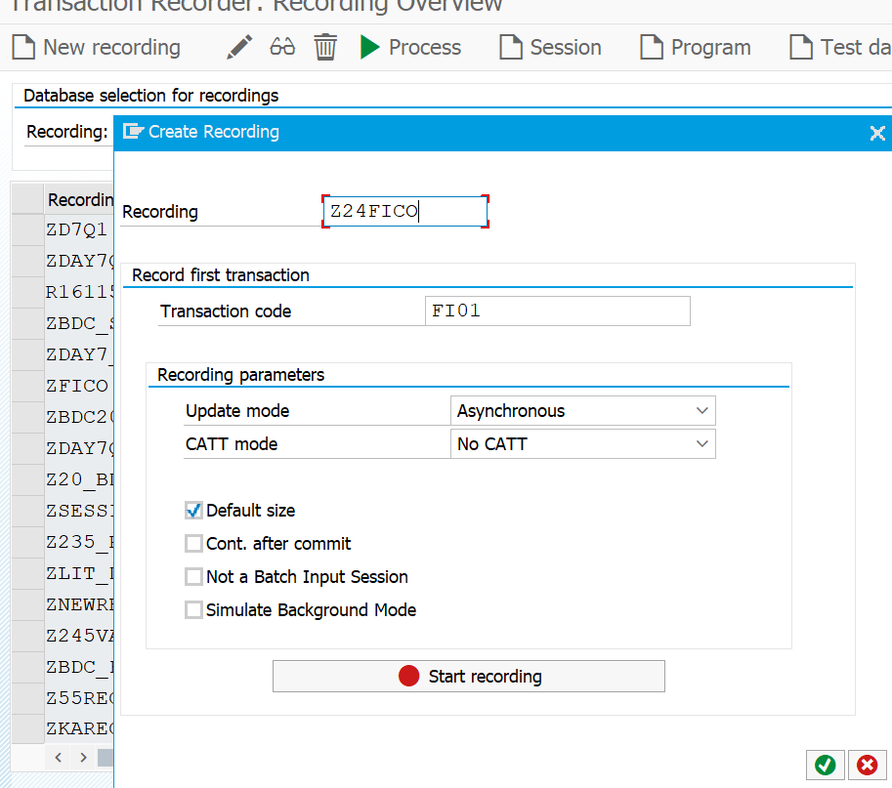

* Enter the Bank country and Key

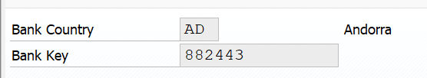

* Now enter the Bank name ,City ,country and street.

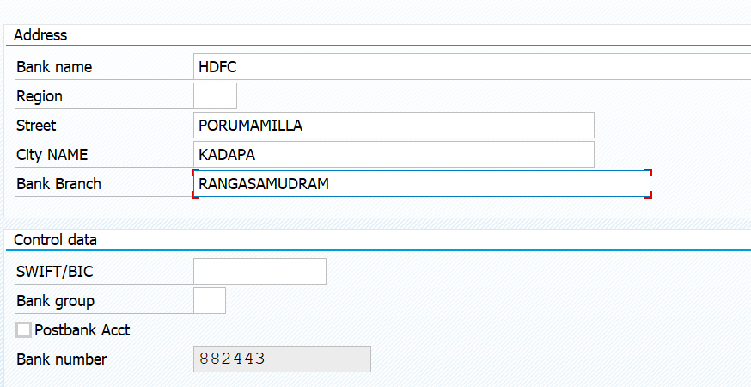

Now Save the Recording.

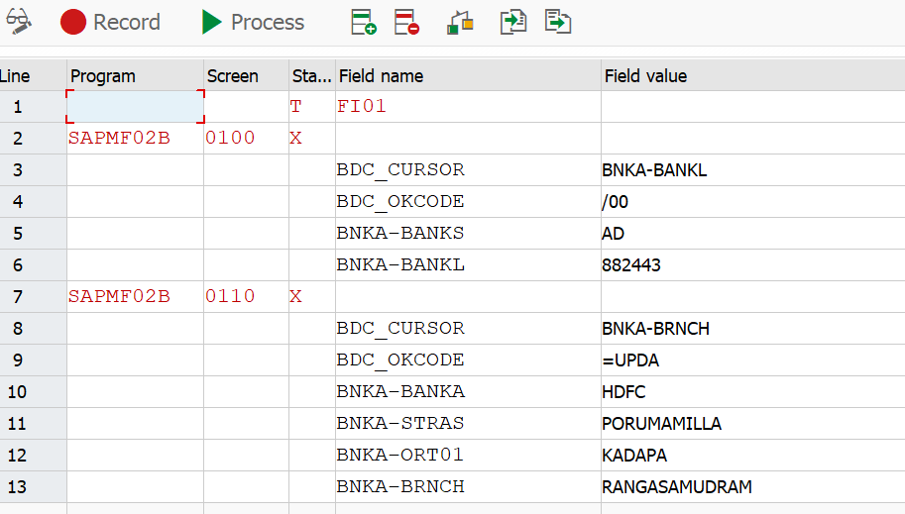

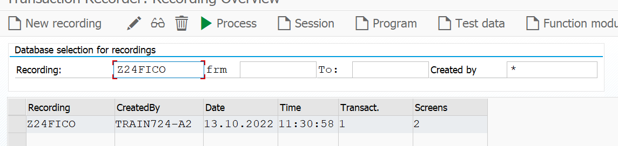

* Now select the created record and created a Program.
* Now BDC program will be created automatically and you can find the structures and dynpro and dynfield subroutines in Include BDCRECX1 main program.Copy them and paste in your source code.

**REPORT:**

*&---------------------------------------------------------------------*  
*& Report Z5236_FICO_BDC  
*&---------------------------------------------------------------------*  
* Description:                  BDC Call Transacion to update data in FI01     
*                                                                      *  
* Author:              BOLLA KASEESWARI                                
*                                                                      *  
* Create date:          12/10/2022                                                                                                                  
REPORT Z24FICOBDC.  
  
types : begin of ty_bnka,  
         banks type bnka-banks,  
         bankl type bnka-bankl,  
         banka type bnka-banka,  
        stras type bnka-stras,  
        ort01 type bnka-ort01,  
        BRNCH type bnka-BRNCH,  
        BNKLZ type bnka-BNKLZ,  
         end of ty_bnka.  
  
         data : it_bnka type table of ty_bnka,  
                wa_bnka type ty_bnka.  
         data : it_bdcdata type table of bdcdata,  
                wa_bdcdata type bdcdata.  
  
         data : bdcmsg type table of bdcmsgcoll.  
         data : file type string.  
  
         parameters : p_file type rlgrap-filename.  
  
  
start-of-selection.  
  
         if  p_file is not initial.  
           file = p_file.  
           ENDIF.  
  
CALL FUNCTION 'GUI_UPLOAD'  
  EXPORTING  
    filename                      = file  
   FILETYPE                      = 'ASC'  
   HAS_FIELD_SEPARATOR           = 'X'  
  
  tables  
    data_tab                      = it_bnka  
  
 EXCEPTIONS  
   FILE_OPEN_ERROR               = 1  
   FILE_READ_ERROR               = 2  
   NO_BATCH                      = 3  
   GUI_REFUSE_FILETRANSFER       = 4  
   INVALID_TYPE                  = 5  
   NO_AUTHORITY                  = 6  
   UNKNOWN_ERROR                 = 7  
   BAD_DATA_FORMAT               = 8  
   HEADER_NOT_ALLOWED            = 9  
   SEPARATOR_NOT_ALLOWED         = 10  
   HEADER_TOO_LONG               = 11  
   UNKNOWN_DP_ERROR              = 12  
   ACCESS_DENIED                 = 13  
   DP_OUT_OF_MEMORY              = 14  
   DISK_FULL                     = 15  
   DP_TIMEOUT                    = 16  
   OTHERS                        = 17  
          .  
IF sy-subrc <> 0.  
* Implement suitable error handling here  
ENDIF.  
  
*perform open_group.  
LOOP AT IT_BNKA INTO WA_BNKA.  
  REFRESH : bdcmsg,IT_BDCDATA.  
  
  
perform bdc_dynpro      using 'SAPMF02B' '0100'.  
perform bdc_field       using 'BDC_CURSOR'  
                              'BNKA-BANKL'.  
perform bdc_field       using 'BDC_OKCODE'  
                              '/00'.  
perform bdc_field       using 'BNKA-BANKS' WA_BNKA-BANKS.  
*                              record-BANKS_001.  
perform bdc_field       using 'BNKA-BANKL' WA_BNKA-BANKL.  
*                              record-BANKL_002.  
perform bdc_dynpro      using 'SAPMF02B' '0110'.  
perform bdc_field       using 'BDC_CURSOR'  
                              'BNKA-BRNCH'.  
perform bdc_field       using 'BDC_OKCODE'  
                              '=UPDA'.  
perform bdc_field       using 'BNKA-BANKA' WA_BNKA-BANKA.  
*                              record-BANKA_003.  
perform bdc_field       using 'BNKA-STRAS' WA_BNKA-STRAS.  
*                              record-STRAS_004.  
perform bdc_field       using 'BNKA-ORT01' WA_BNKA-ORT01.  
*                              record-ORT01_005.  
perform bdc_field       using 'BNKA-BRNCH' wa_BNKA-BRNCH.  
*                              record-BRNCH_006.  
perform bdc_field       using 'BNKA-BNKLZ' WA_BNKA-BNKLZ.  
*                              '753443532'.  
  
*perform bdc_transaction using 'FI01'.  
  
  
   CALL TRANSACTION 'FI01' USING IT_BDCDATA MODE 'A' UPDATE 'A' MESSAGES INTO BDCMSG.  
  
*perform close_group.  
ENDLOOP.  
  
  
DATA : WA_BDCMSG LIKE LINE OF BDCMSG.  
IF BDCMSG IS NOT INITIAL.  
  LOOP AT BDCMSG INTO WA_BDCMSG.  
    WRITE:/ WA_BDCMSG-TCODE,  
           WA_BDCMSG-MSGTYP,  
           WA_BDCMSG-MSGV1,  
            WA_BDCMSG-FLDNAME.  
    CLEAR WA_BDCMSG.  
    ENDLOOP.  
    ENDIF.  
  
FORM BDC_DYNPRO USING PROGRAM DYNPRO.  
  CLEAR WA_BDCDATA.  
  WA_BDCDATA-PROGRAM  = PROGRAM.  
  WA_BDCDATA-DYNPRO   = DYNPRO.  
  WA_BDCDATA-DYNBEGIN = 'X'.  
  APPEND WA_BDCDATA TO IT_BDCDATA.  
ENDFORM.  
  
*----------------------------------------------------------------------*  
*        Insert field                                                  *  
*----------------------------------------------------------------------*  
FORM BDC_FIELD USING FNAM FVAL.  
*  IF FVAL <> NODATA.  
    CLEAR WA_BDCDATA.  
    WA_BDCDATA-FNAM = FNAM.  
    WA_BDCDATA-FVAL = FVAL.  
    APPEND WA_BDCDATA TO IT_BDCDATA.  
*  ENDIF.  
ENDFORM.

OUTPUT: Read data from the flat file

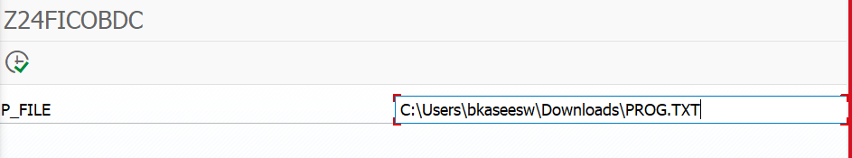

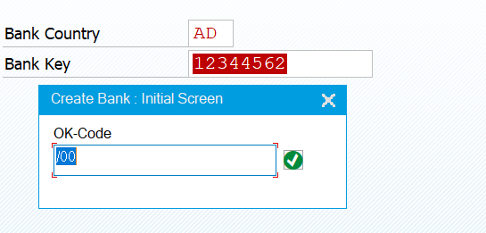

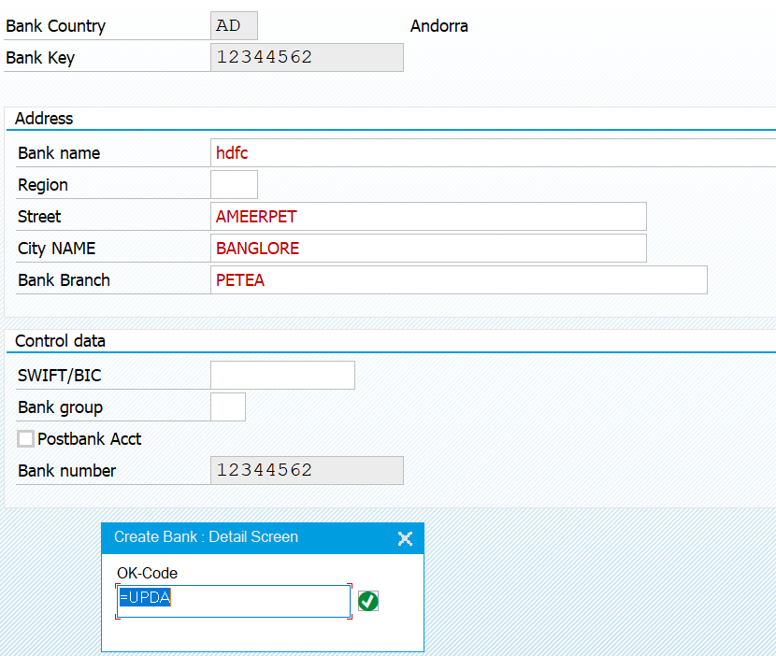

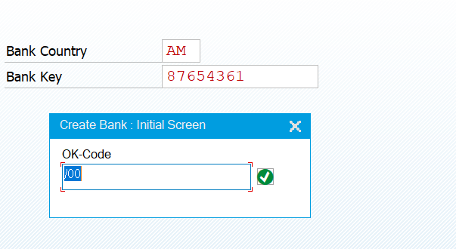

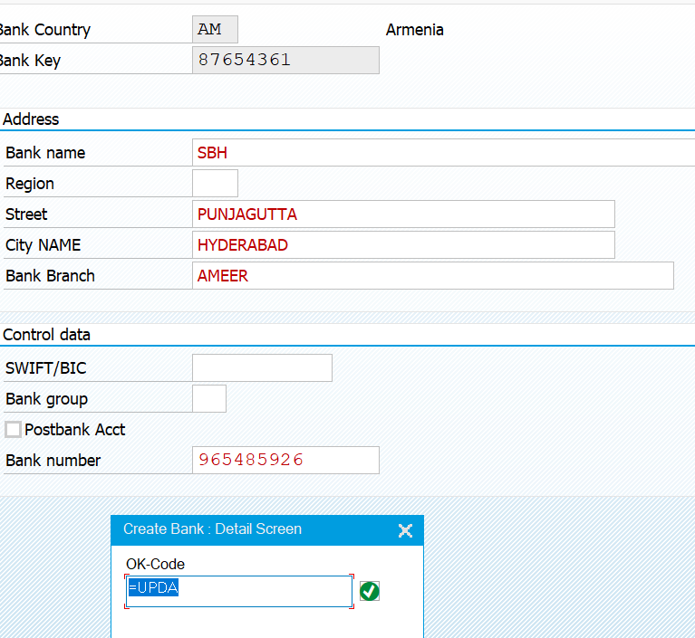

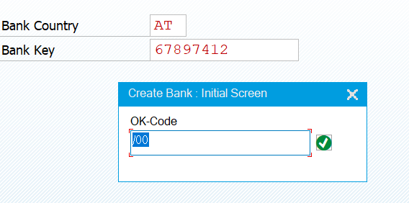

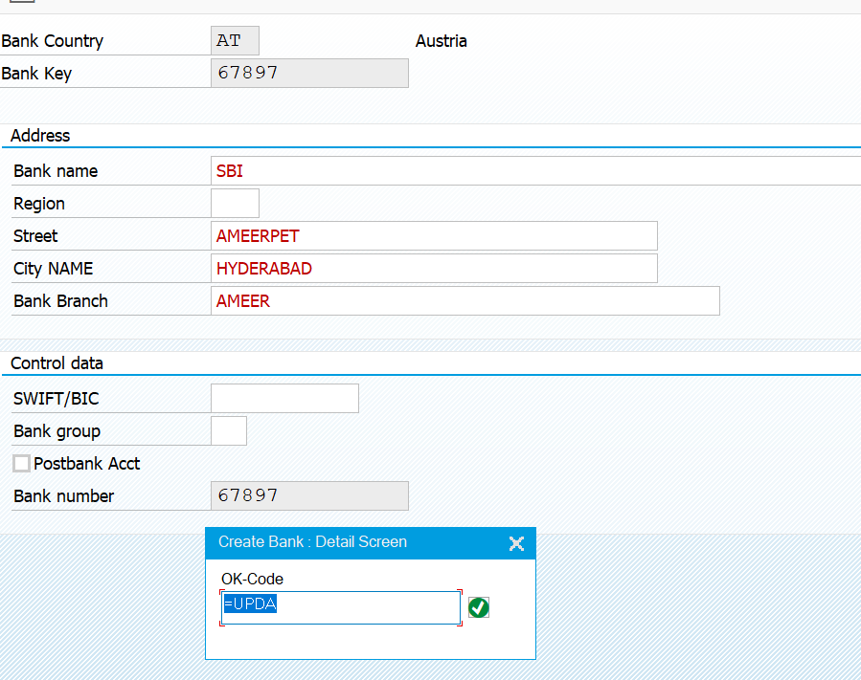

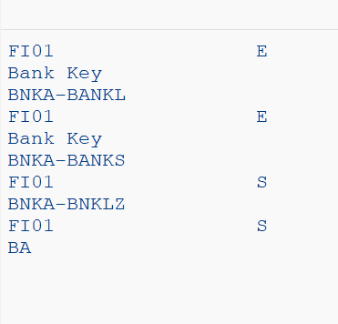

**Q2**. **Create an Upload program Using BDC Session Method to update data in MM02(Material Change).**

**STEP 1: created the new record in SHDB.**

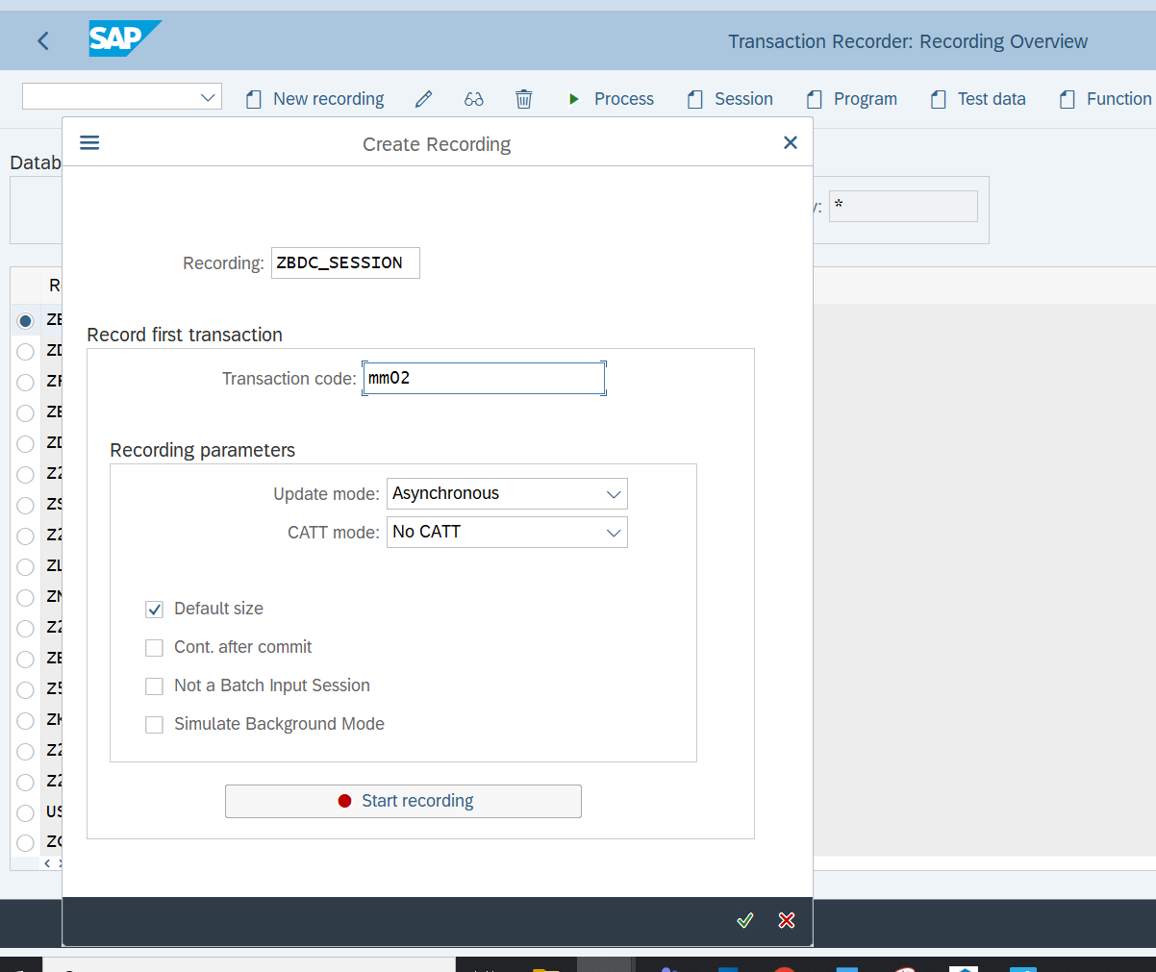

Now Save the Recording .

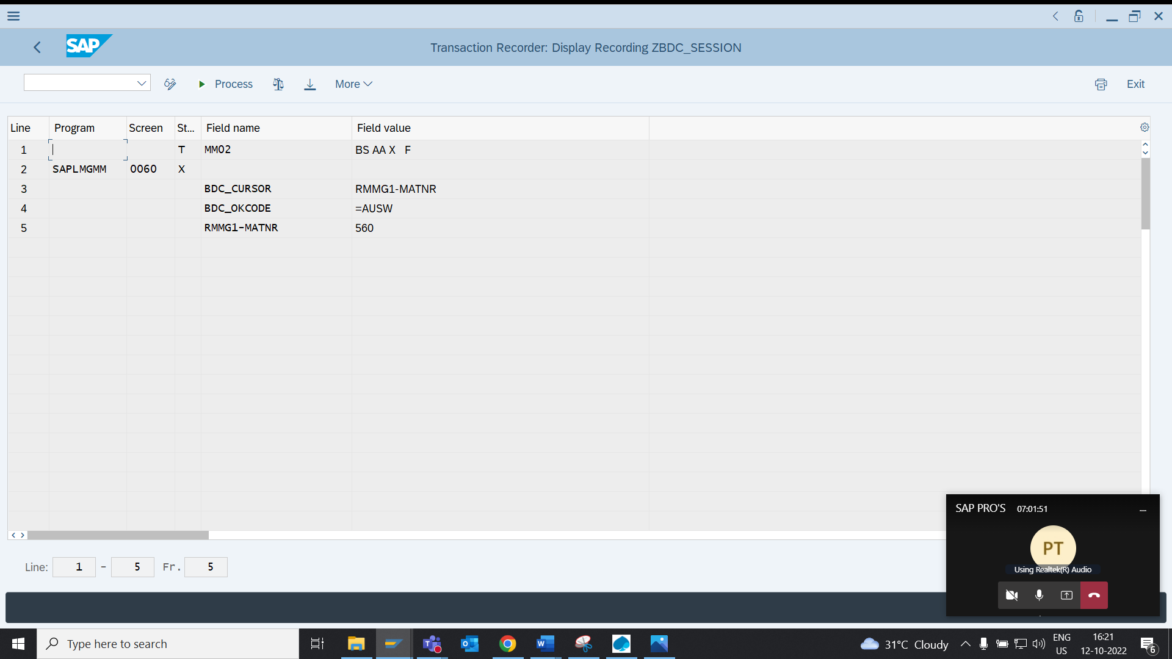

* Now select the created record and click on Program and create the program.
* Then BDC program will be created automatically and you can find the structures and dynpro and dynfield subroutines in Include BDCRECX1 main program.Copy them and paste in your source code.

**REPORT:**

*&---------------------------------------------------------------------*  
*& Report Z5236_BDC_SESSION  
*&---------------------------------------------------------------------*  
* Description:           BDC SESSION METHOD USING MM02                                              *  
*                                                                      *  
* Author:     BOLLAKASEESWARI                                                  *  
*                                                                      *  
* Create date:                                                         *  
*                                                                      *  
*&---------------------------------------------------------------------*  
  
REPORT Z5236_BDC_SESSION.  
  
TYPES:BEGIN OF TY_MAT,  
       MATNR TYPE MATNR,  
       END OF TY_MAT.  
  
DATA: IT_MA TYPE TABLE OF TY_MAT,  
      WA_MA TYPE TY_MAT,  
  F_NAME TYPE STRING.  
  
  
DATA:   BDCDATA LIKE BDCDATA .   
*       messages of call transaction  
DATA:   MESSTAB LIKE BDCMSGCOLL.  
  
  
PARAMETERS : path TYPE rlgrap-filename OBLIGATORY.  
  
AT SELECTION-SCREEN ON VALUE-REQUEST FOR path .  
  
  CALL FUNCTION 'F4_FILENAME'  
  
    EXPORTING  
      program_name  = syst-cprog  
      dynpro_number = syst-dynnr  
      field_name    = 'PATH'  
    IMPORTING  
      file_name     = path.  
  
START-OF-SELECTION.  
F_NAME = PATH.  
CALL FUNCTION 'GUI_UPLOAD'  
  EXPORTING  
    filename                      = F_NAME  
   FILETYPE                      = 'ASC'  
   HAS_FIELD_SEPARATOR           = 'X'  
  tables  
    data_tab                      = IT_MA  
* CHANGING  
*   ISSCANPERFORMED               = ' '  
* EXCEPTIONS  
*   FILE_OPEN_ERROR               = 1  
*   FILE_READ_ERROR               = 2  
*   NO_BATCH                      = 3  
*   GUI_REFUSE_FILETRANSFER       = 4  
*   INVALID_TYPE                  = 5  
*   NO_AUTHORITY                  = 6  
*   UNKNOWN_ERROR                 = 7  
*   BAD_DATA_FORMAT               = 8  
*   HEADER_NOT_ALLOWED            = 9  
*   SEPARATOR_NOT_ALLOWED         = 10  
*   HEADER_TOO_LONG               = 11  
*   UNKNOWN_DP_ERROR              = 12  
*   ACCESS_DENIED                 = 13  
*   DP_OUT_OF_MEMORY              = 14  
*   DISK_FULL                     = 15  
*   DP_TIMEOUT                    = 16  
*   OTHERS                        = 17  
          .  
IF sy-subrc <> 0.  
* Implement suitable error handling here  
ENDIF.  
  
CALL FUNCTION 'BDC_OPEN_GROUP'  
 EXPORTING  
   CLIENT                    = SY-MANDT  
*   DEST                      = FILLER8  
   GROUP                     = 'AKS'  
*   HOLDDATE                  = FILLER8  
   KEEP                      = 'X'  
   USER                      = sy-uname   
   PROG                      = SY-CPROG  
=  
 EXCEPTIONS  
   CLIENT_INVALID            = 1  
   DESTINATION_INVALID       = 2  
   GROUP_INVALID             = 3  
   GROUP_IS_LOCKED           = 4  
   HOLDDATE_INVALID          = 5  
   INTERNAL_ERROR            = 6  
   QUEUE_ERROR               = 7  
   RUNNING                   = 8  
   SYSTEM_LOCK_ERROR         = 9  
   USER_INVALID              = 10  
   OTHERS                    = 11  
          .  
IF sy-subrc <> 0.  
* Implement suitable error handling here  
ENDIF.  
  
  
  
LOOP AT IT_MA INTO WA_MA.  
  REFRESH : MESSTAB, BDCDATA.  
  
perform bdc_dynpro      using 'SAPLMGMM' '0060'.  
perform bdc_field       using 'BDC_CURSOR'  
                              'RMMG1-MATNR'.  
perform bdc_field       using 'BDC_OKCODE'  
                              '=AUSW'.  
perform bdc_field       using 'RMMG1-MATNR'  
                               WA_MA-MATNR.  
  
  
  
CALL FUNCTION 'BDC_INSERT'  
 EXPORTING  
   TCODE                  = 'MM02'  
  TABLES  
    DYNPROTAB              = BDCDATA  
 EXCEPTIONS  
   INTERNAL_ERROR         = 1  
   NOT_OPEN               = 2  
   QUEUE_ERROR            = 3  
   TCODE_INVALID          = 4  
   PRINTING_INVALID       = 5  
   POSTING_INVALID        = 6  
   OTHERS                 = 7  
          .  
IF SY-SUBRC <> 0.  
* Implement suitable error handling here  
ENDIF.  
clear : WA_MA.  
endloop.  
  
CALL FUNCTION 'BDC_CLOSE_GROUP'  
 EXCEPTIONS  
   NOT_OPEN          = 1  
   QUEUE_ERROR       = 2  
   OTHERS            = 3  
          .  
IF SY-SUBRC <> 0.  
* Implement suitable error handling here  
  message 'Error while creating bdc session' TYPE 'E'.  
ELSE.  
   MESSAGE 'BDC session created' TYPE 'S'.  
  
ENDIF.  
  
FORM BDC_DYNPRO USING PROGRAM DYNPRO.  
  CLEAR BDCDATA.  
  BDCDATA-PROGRAM  = PROGRAM.  
  BDCDATA-DYNPRO   = DYNPRO.  
  BDCDATA-DYNBEGIN = 'X'.  
  APPEND BDCDATA.  
ENDFORM.  
  
*----------------------------------------------------------------------*  
*        Insert field                                                  *  
*----------------------------------------------------------------------*  
FORM BDC_FIELD USING FNAM FVAL.  
  
    CLEAR BDCDATA.  
    BDCDATA-FNAM = FNAM.  
    BDCDATA-FVAL = FVAL.  
    APPEND BDCDATA.  
  
ENDFORM.

**OUTPUT:**

**selection screen:**



* Now program successfully transferred the data through two recorded screens of FI01 transaction code .

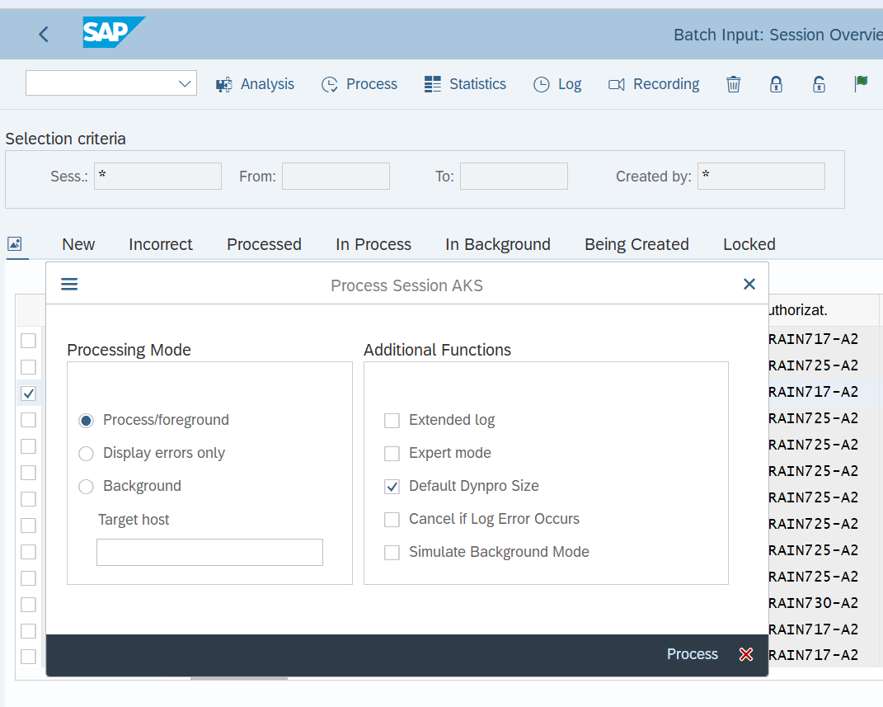

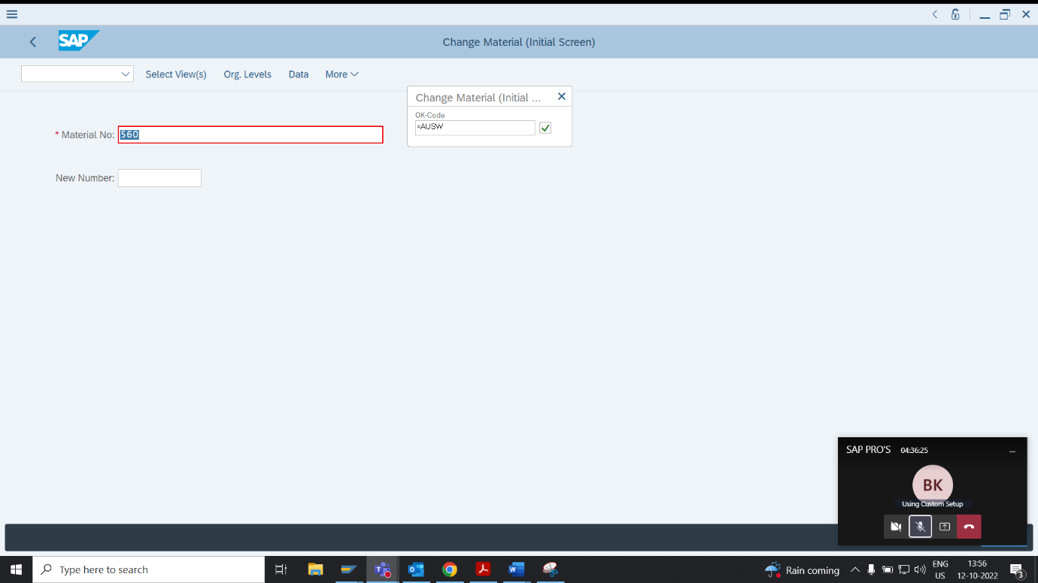

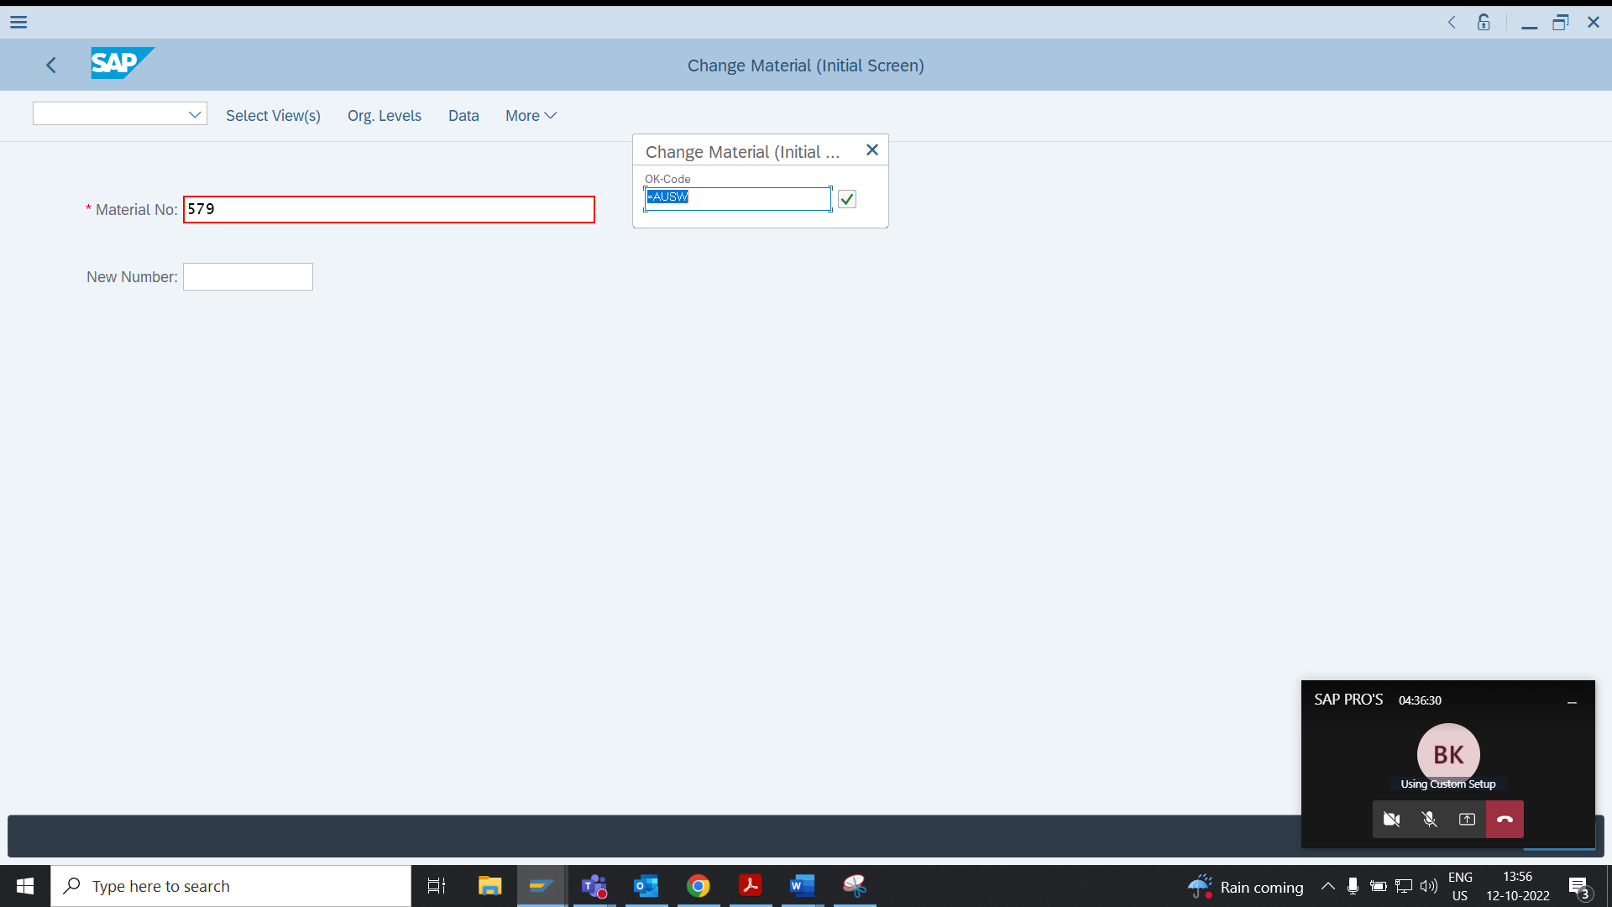

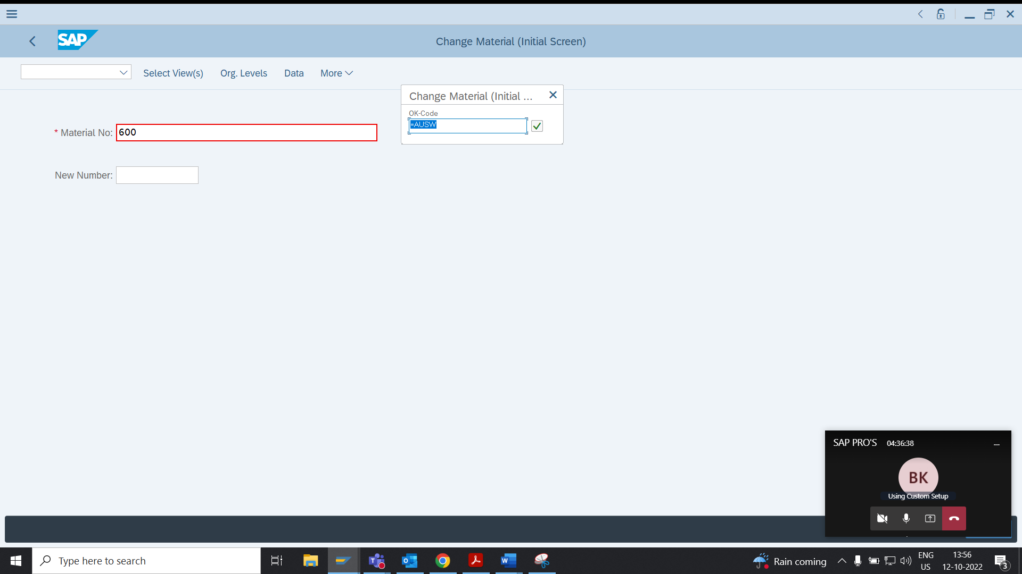

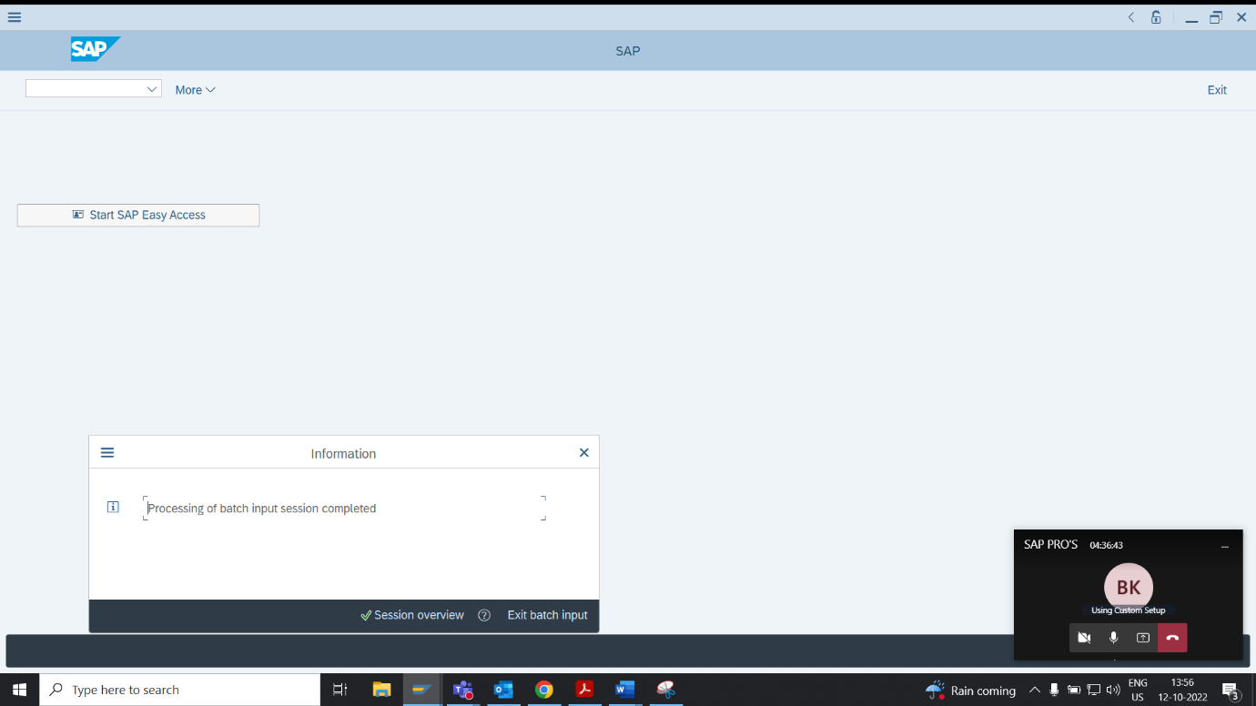

* Now program successfully transferred the data through two recorded screens of FI01 transaction code .

**3-Q Create a LSMW to update Data in ~~Transaction XD02.(Customer Key) -~~ Try LSMW with MM01, MM02, VA01 etc**

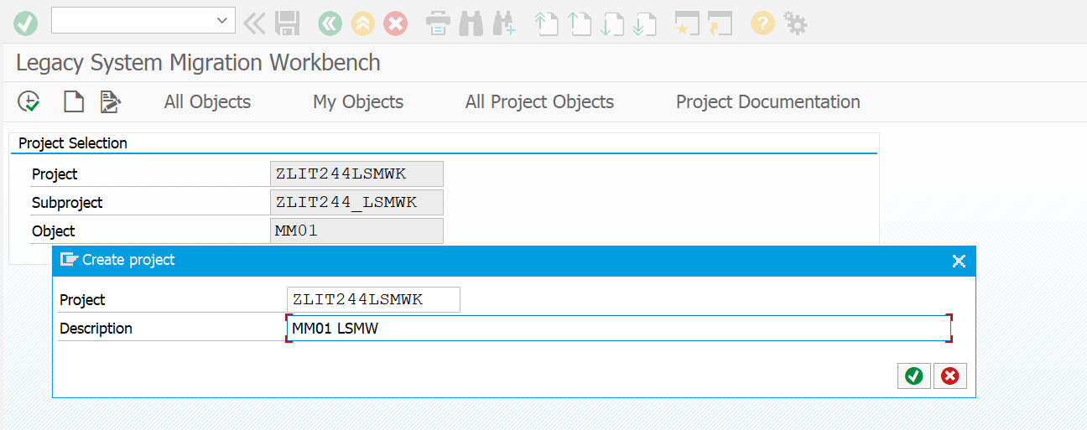

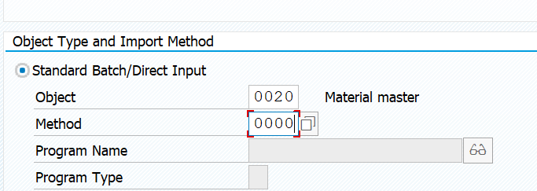

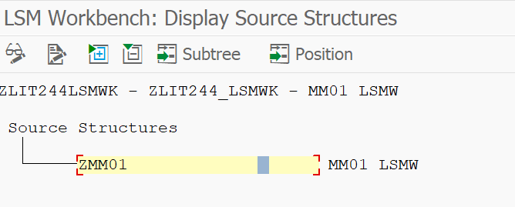

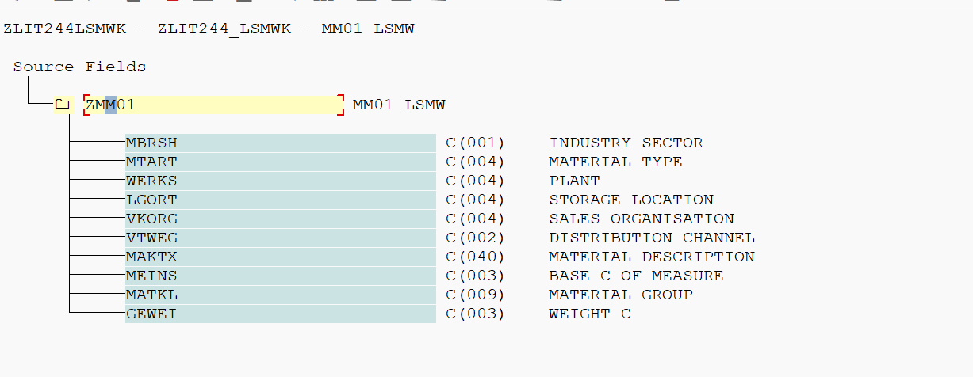

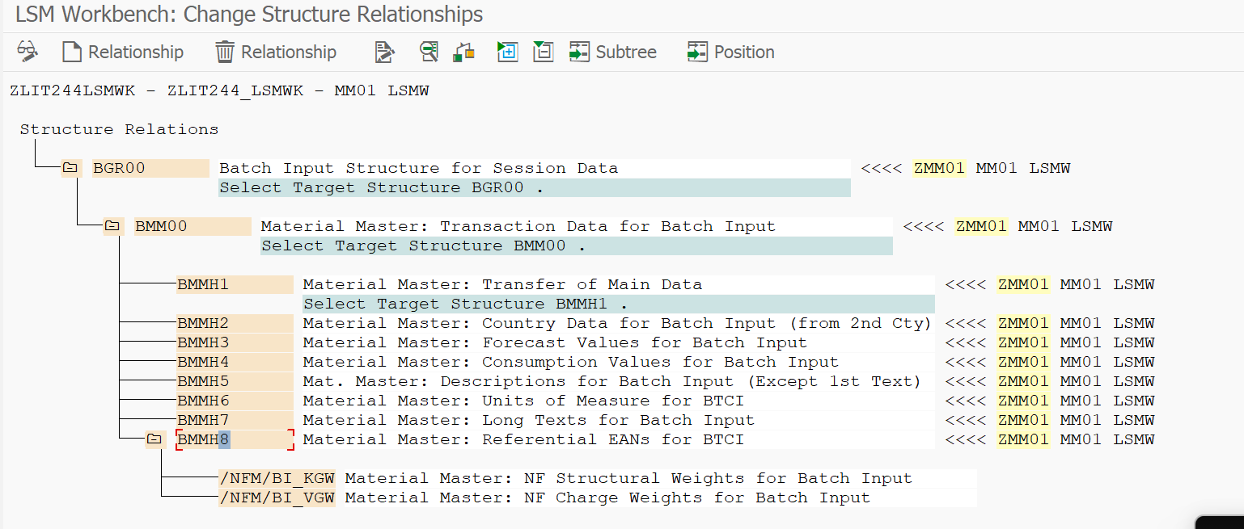

**AUTO FIELD MAPPING**

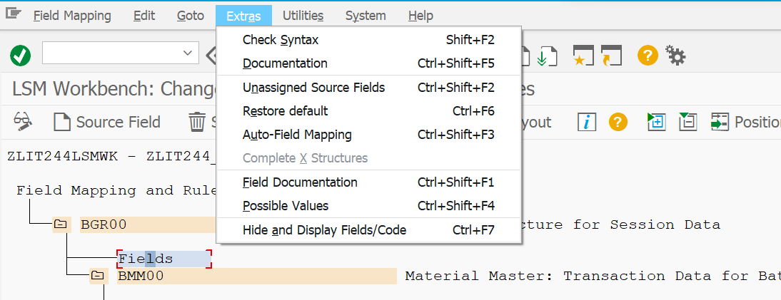

**ACCEPT PROPOSAL FOR ALL THE FIELDS**

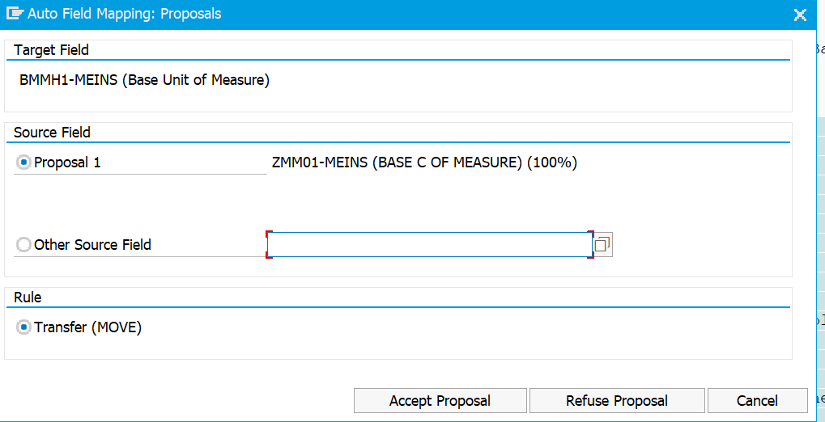

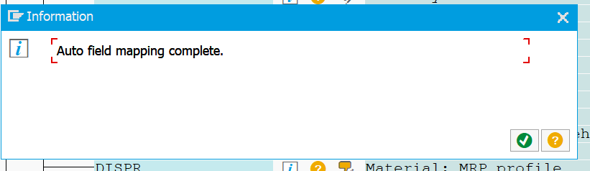

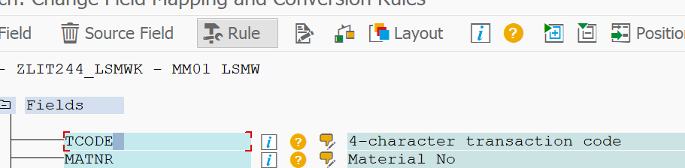

**MAINTAINING REQUIRED FIELDS MANUALLY**

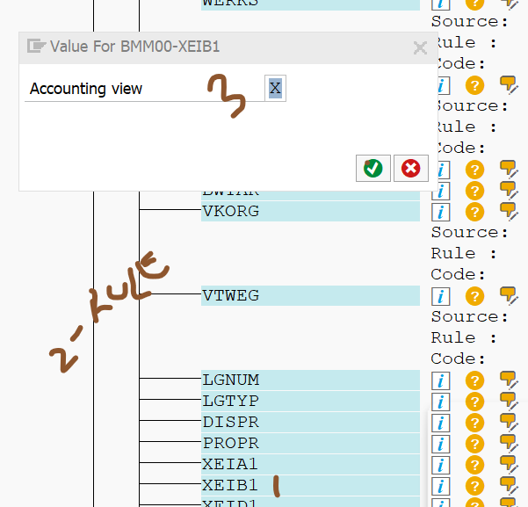

**UPLOADING NOTEPAD FILE IN SPECIFIED FIELDS**

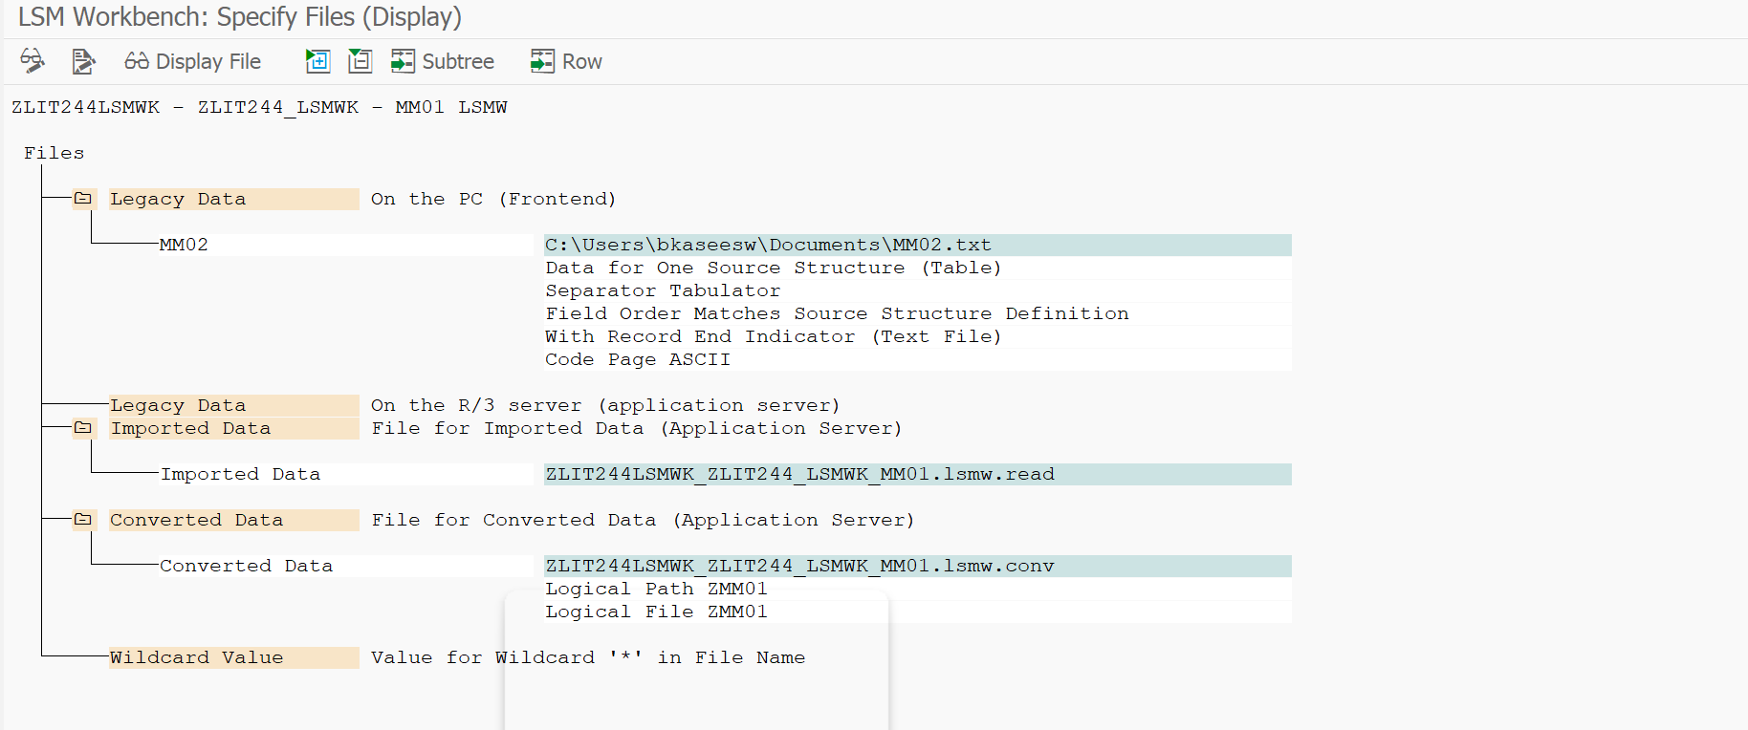

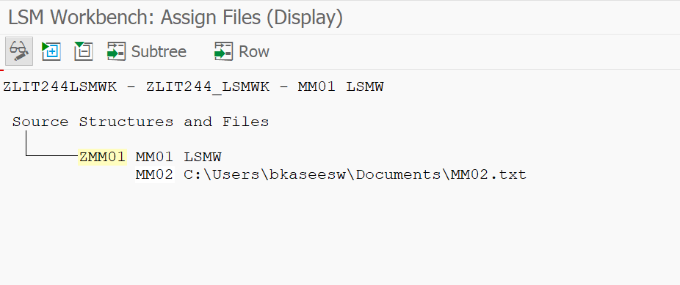

**READ DATA**

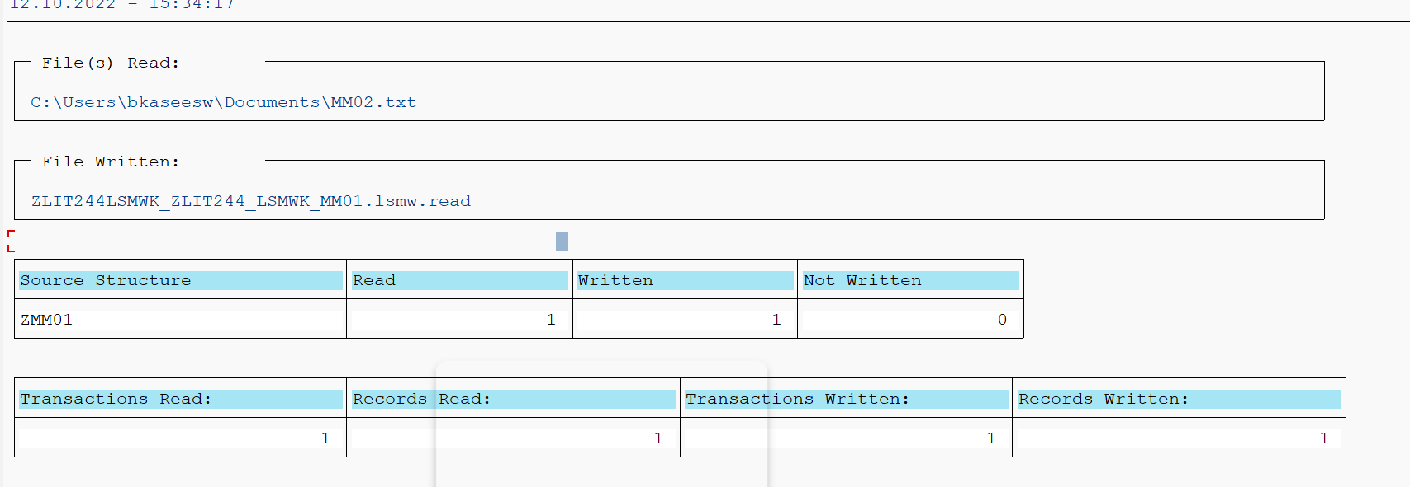

**DATA DISPLAY**

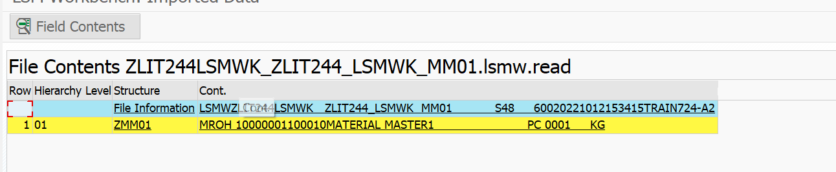

**CONVERTING FILE INTO CSV**

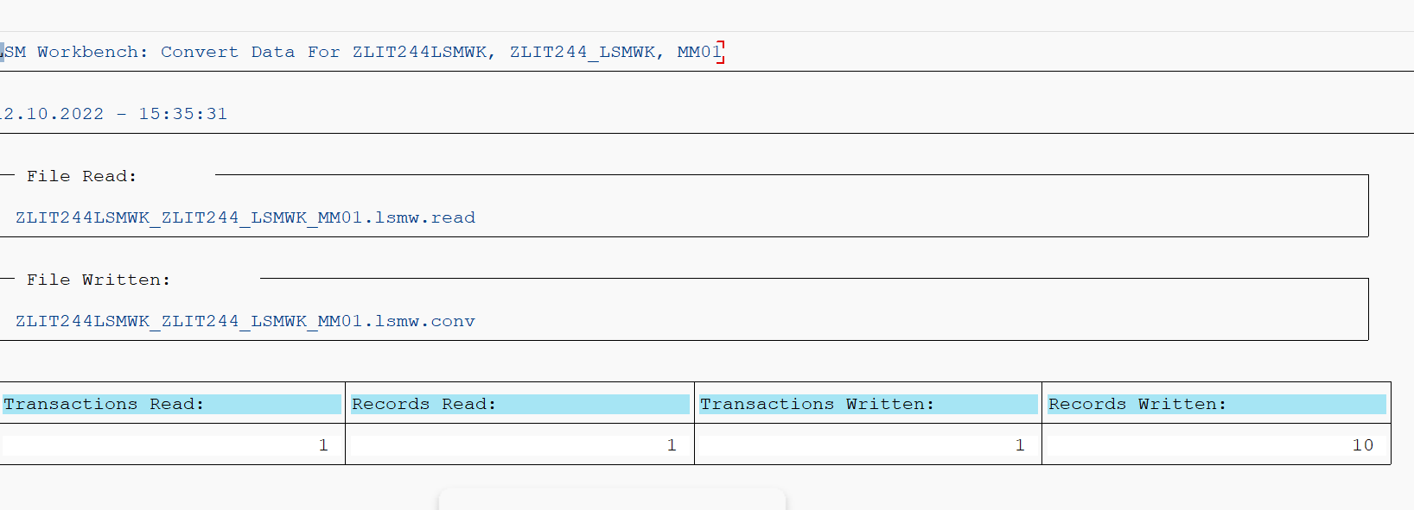

**DISPLAYING CONVERTED DATA AND MANUALLY CHANGED FIELDS**

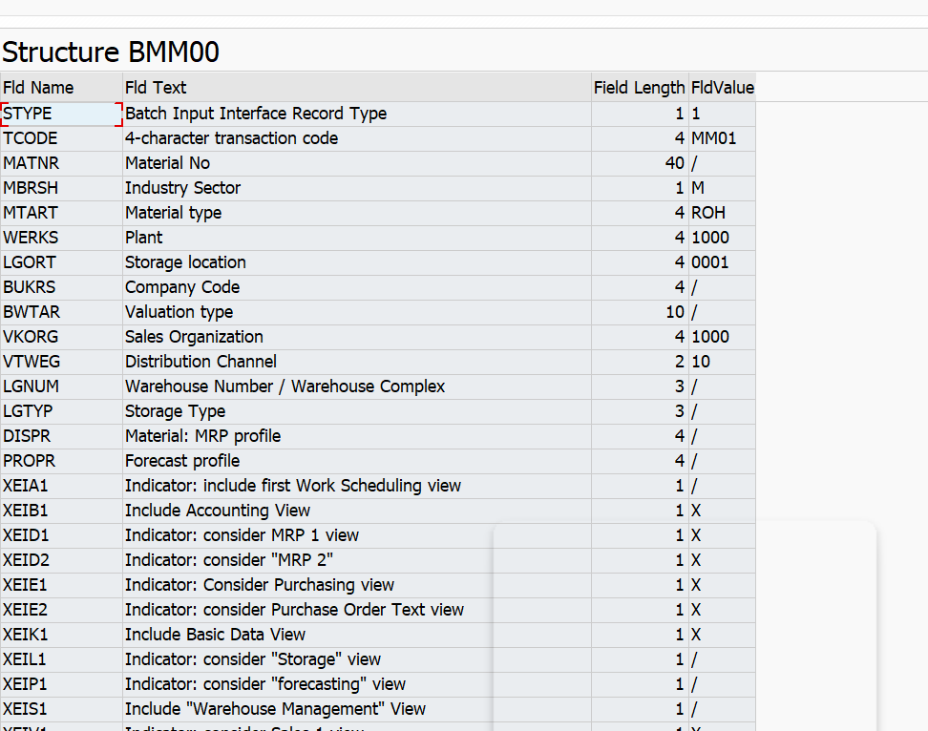

**DIRECT INPUT SESSION**

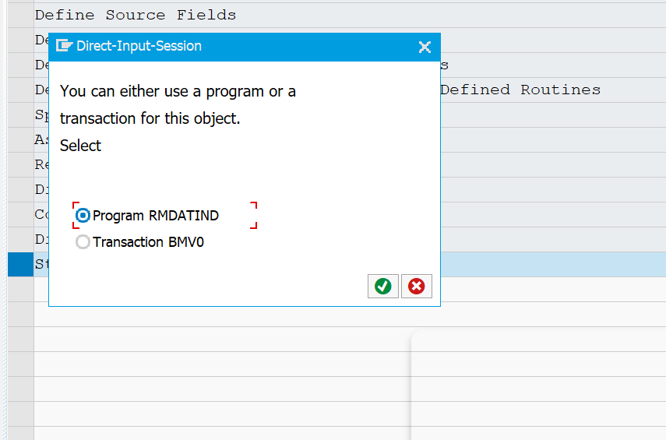

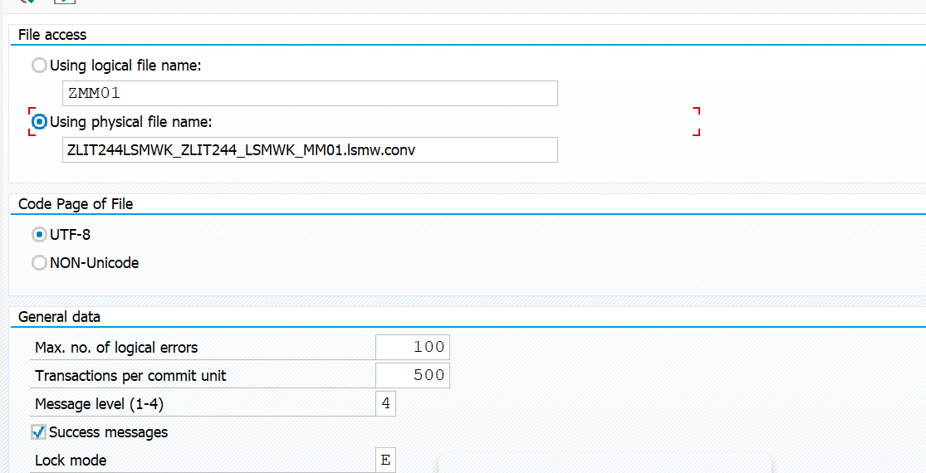

**RUN TIME ERROR DUE TO SERVER ISSUE - CHANGE IN KNA1 TABLE**

